If you would like to make some playdough at home with your child(ren), we have attached some simple recipes for you to try.
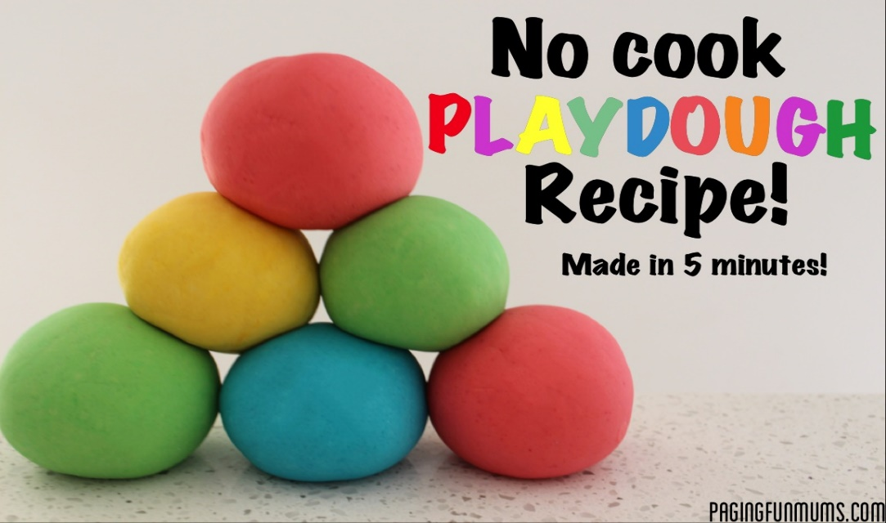
Have fun!!!

Play dough recipe
2 cups flour
¾ cup salt
4teaspoons of cream of tartar
2 cups warm water
2 tablespoons of oil
Mix the flour, salt and cream of tartar.
Add the warm water, oil and food colouring.
Mix/knead together.

