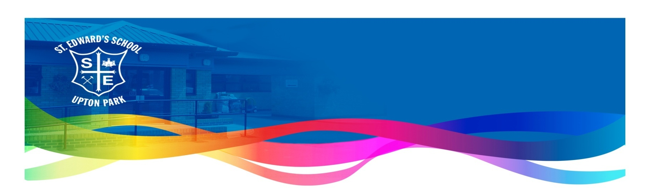
Pupil Voice

What our pupils say about Music:

Year 6:

“During Black History Month we studied Jazz music. Jazz music use guitars, trumpets and saxophones.”
“I like listening to different types of instruments and trying to understand lyrics too.”
I have Rock Steady lessons. I play the guitar and we played Rick Astley’s ‘Never Gonna Give You Up’ song.”
“I am part of the Commonwealth Choir. I sang at the Queen’s Jubilee with a song called ‘Sing’ which was also sung by Kiara Settle who is a singer from The Greatest Showman.”
“We listen to different types of music and we have analysed the Jazz and classical styles.”
“Music is exciting and emotional so it can change your mood.”
“We use music for warm up and cool down sessions.”
“I have learned about some instruments such as the piano, cello, bass and drums. Some of these instruments are known as wind, brass, strings or percussion.”
“We learned a Japanese song and also a new song that I did not know of called Myopia.”
“In Year 5 I was in the Commonwealth Choir and I am grateful for that as I got to express what I do best.”

Year 5:

“We have a music lesson once a week and this term we are making our own version of a well-known song.”
“We use instruments to make our own version of an Adele song. Some of the instruments will be a triangle, a tambourine or a xylophone.”
“Sometimes we login online to test out pieces of music we are making.”
“We have learned about Jazz music which uses instruments such as keyboards, violin and saxophones.”
“Jazz is an old style of music that was created in the 1920’s.”
“Some of the new words we have learned are chorus, verse and tempo.”
“The high notes and low notes allow you to change the music so it sounds different in places.”
“In Year 3 we learned how to play the ukulele and in Year 4 we are learning to play the violin.”
“It is interesting and we have learned about the music of Billy Holiday, Louis Armstrong, Bob Dylan and Duke Ellington.”

Year 4:

“We learned to play the violin which is a stringed instrument that has tuning pegs on it that helps in changing the sound of the music.”
“Some of the artists we have studied are Jacqueline Du Pere who is a British cellist and Mozart. Mozart’s music is classical which was created a long time ago but is still popular now.”
“There are three types of elements which are rhythm, harmony and tempo.”
“We have learned about sound, pitch and waves which are needed to listen to music and create pieces of music.”
“We have hymn practice once a week so that when we go to church we can sing the hymns confidently.”
“We record our learning in our music books and we have key words like crotchet, minimum and semi-breve.”
“Rock Steady lessons are great as we get to play different instruments and then we will be part of a performance and we can book instruments online.”
“The Commonwealth Choir has been to the Indian Embassy to perform and we were also part of the Queen’s Jubilee celebrations with Sky News recording us.
“Bear’s Got Talent is a good opportunity to showcase our musical talents.”

Year 3:

“It is fun learning how to play the ukulele and I have learned the names of new notes like the F Sharp which means the music changes.”
“In Rock Steady we played a song called ‘Human’ and I am part of the group on the key board. We have learned different songs in Rock Steady and music makes you feel things and makes you feel better.”
In the Nativity in Year 2, we role-played the birth of Jesus and we sang songs to celebrate this.”
“I like music because it is exciting and we learn about beat, harmony, tempo and singing. Tempo means how fast or slow the song is.”
“If something is hard we learn from our mistakes and we keep practising. Also our teacher helps us understand.”
“We are learning to play the ukulele. The chords on the ukulele help change the sound of the music.”
“We sing worship songs during Hymn Practice on Tuesdays.”
“We are learning a Christmas song in Performing Arts Club which is after school.”
“Next year I would like to be part of the Commonwealth Choir – they have performed in different places including the Queen’s Jubilee.”
Year 2:

“We have learned about pulse. This means to listen to the rhythm.”
“Moving our bodies helps us understand the music.”
“If we listen and concentrate we can then tap to the music.”
“I love music and singing, we have music once a week but also everyday as we are learning our Nativity songs for Christmas like Ho Ho Ho.”
“I would like to play the piano and I want to be a singer and sing loud like heavy metal.”
“In Reception I learned the ABC song and Twinkle, Twinkle Little Star.”
“When there are no words and only music it is called an instrumental.”

Year 1:

“I like the beat and rhythm in the song, we use our hands to count the beat.”
“We have learned about different instruments like the piano, drums and guitars.”
“I have used the drums to make music and I used my hands to make different sounds.”
“I play the keyboard at home and at school I play the drums which make aloud sound.”
“We sing number songs like no more monkeys jumping on the bed.”
“Music lessons are so good and exciting.”
“I have learned that music can be fast or slow.”
“Music is like an instrument with your voice.”

Reception:

“We can use our feet to make some sounds that are loud or soft.”

“We use our hands and fingers to tap a sound or beat.”

“Music can make you feel scared, sad or happy like the music on the board.”

“The music makes me feel like I am in a forest walking in the dark.”

“I like the song Twinkle, Twinkle Little Star.”

“I used the bells to play the Happy song.”

Nursery:

“You can use a beater for the drum.”

Your hands and finger tips make different sounds on the drum.”

“I shake the instrument to make it work.”

“We have learned the song Jesus loves us.”

