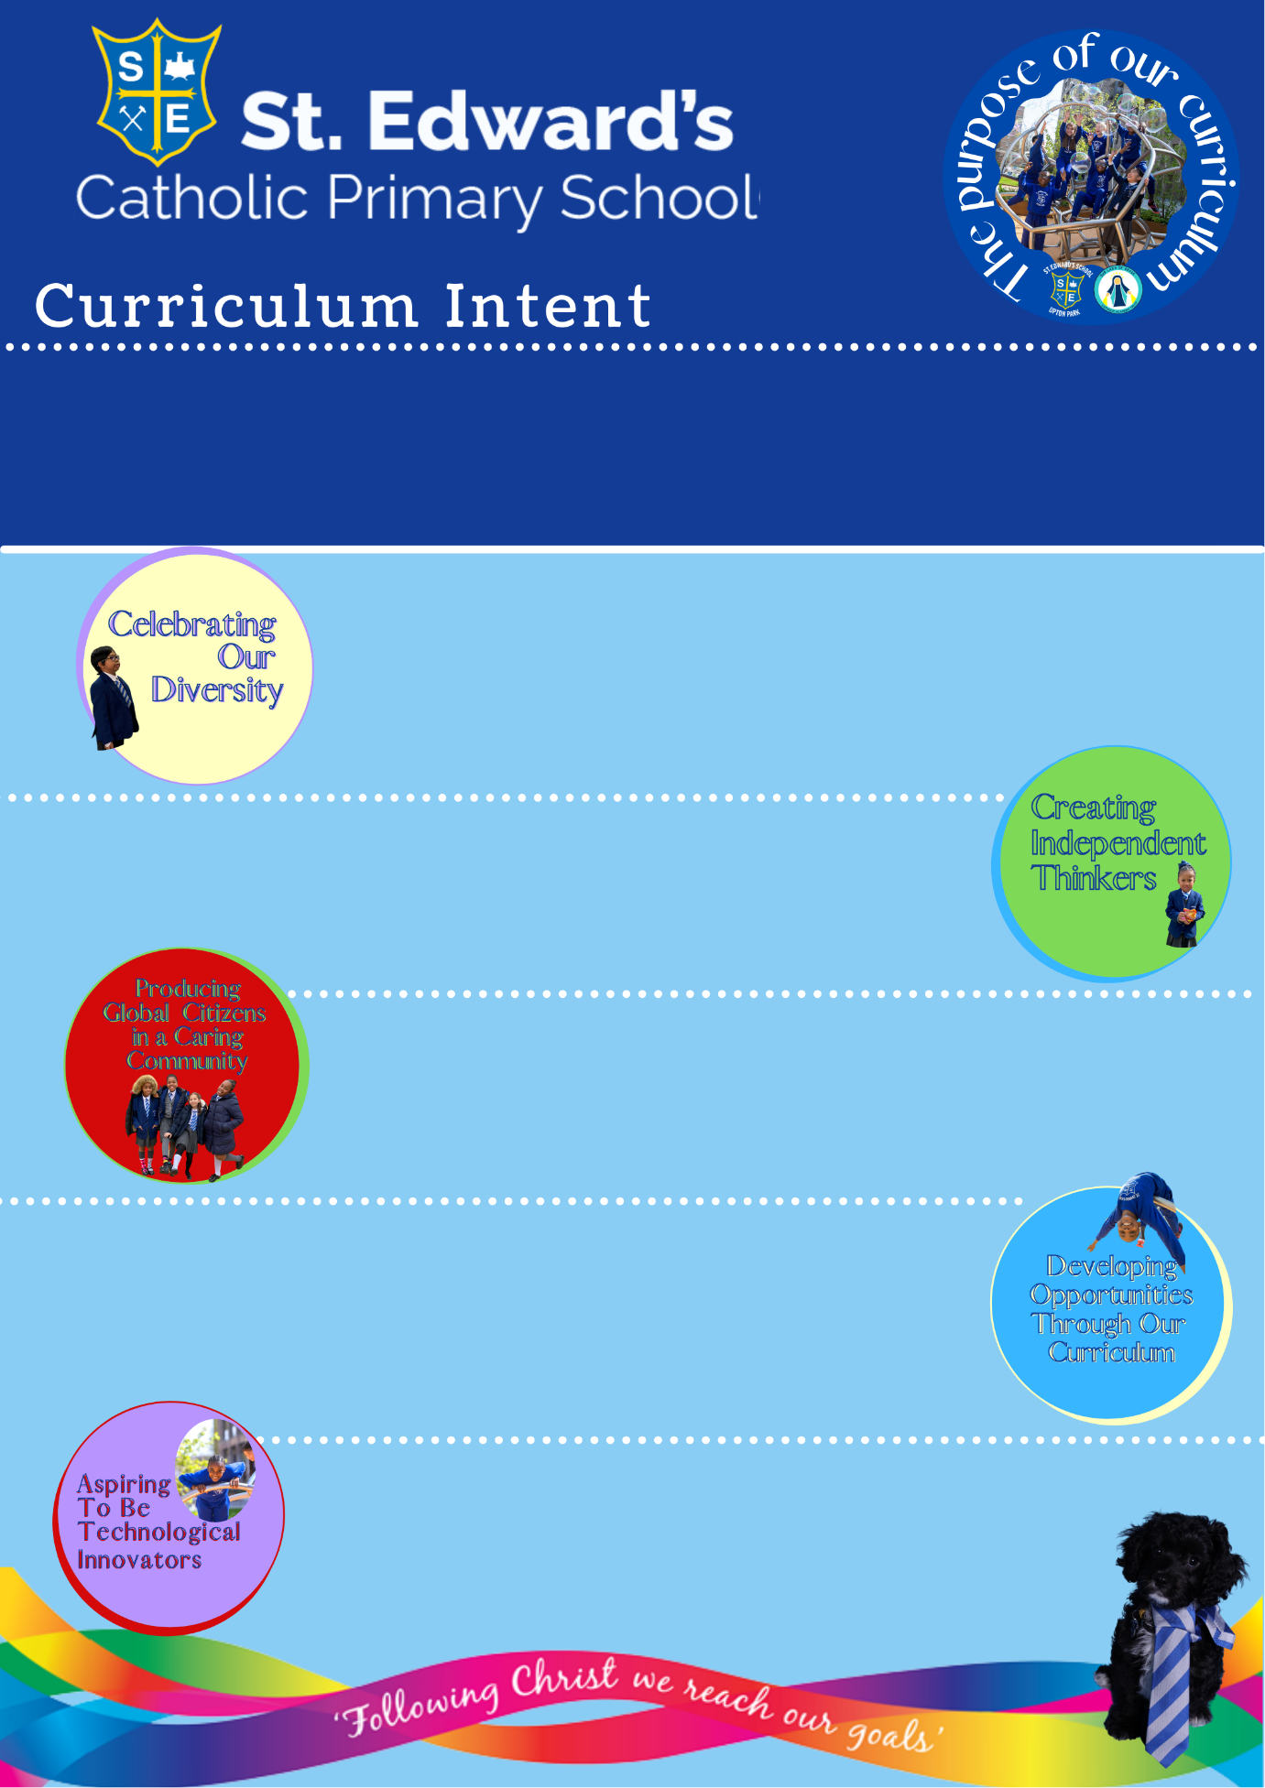
We are learning to develop our own ideas, make links and develop strategies for doing things. We are encouraged to think independently and solve problems creatively.

We are young, technological innovators. We enjoy using technology in our everyday learning experiences from interactive lessons to programming toys to perform a series of commands.

Play is one of the primary ways in which children learn. Our curriculum is designed to ensure children have opportunities to explore, investigate, recreate and understand the world.

We are learning about the world and our impact on it. We are learning about nature and the animals we share our world with. We know about the importance of being part of a caring community.

We are learning that we all have similarities and differences that make us special. We celebrate our diversity by learning about different cultures and traditions and learning a new language each term.

EYFS
At St Edward’s Catholic Primary School it is our belief that EYFS is essential for building the foundations for lifelong learning. Our curriculum provides a play-based and experiential learning environment, coupled with focussed teaching and basic skills. Children are provided with opportunities to engage in planned, focussed activities as well as child-initiated and free flow activities via our indoor and outdoor provision.

EYFS
“Every child deserves the best possible start in life and the support that enables them to fulfil their potential. Children develop quickly in the early years and a child’s experiences between birth and age five have a major impact on their future life chances.” DfE: Statutory Framework for the Early Years Foundation Stage 2021
The learning experiences within our Early Years are linked to the seven areas of learning and development within the EYFS framework.
Personal, Social and Emotional Development | Communication and Language
Physical Development | Literacy
Mathematics | Understanding the World
Expressive Arts and Design
Topics
Me & My Family (N)  At School (R)  Black History Month | Weather & Environment (N)  Dinosaurs (R)  Birthdays (R)
Superheroes (N)  People Who Help Us (NR)  Traditional Tales (R) | Growth & Change (N)  Planting & Growing (R)  Animals and their young (R)
Journeys & Transport (N)  Travel & Transport (R) | Traditional Tales & Nursery Rhymes (N)  Aliens (R)  Space (R)
Context

Nursery
Me & My Family (N)  - Children show an interest in the lives of people who are familiar.  - They build relationships with friends and teachers.  - Remembering and talking about significant events and experiences.  - Gaining self-confidence and self-awareness – separating from parents/carers.  - Expressing own feelings. | Weather & Environment (N)  - Seasons – Looking at changes that occur in Autumn.  - Talk about and asks questions about the place where they live or the natural world.  - Talk about notices changes in the weather & environment.  - Share experiences and talks about the importance of Advent and Christmas.
Superheroes (N)  People who help us (N)  - Seasons – Looking at changes that occur in Winter/Spring  - Noticing detailed features of local environment.  - Show an interest in different occupations and ways of life. | Growth & Change (N)  - Seasons – Noticing detailed features of local environment.  - Looking at changes that occur in Spring.  - Beginning to show an understanding of growth, decay and changes over time.  - Shows care and concern for living things.
Journeys & Transport (N)  - Use a range of ways to move confidently and freely, negotiating space and adjusting speed.  - Talk about different types of transport and how they like to travel.  - Shows an understanding of positional language. | Traditional Tales & Nursery Rhymes (N)  - Joins in with and anticipating key events and phrases in rhymes and stories.  - Describes main characters and events.  - Suggests how the story might end.

Reception
At School  Black History Month  - Beginning to accept the needs of others, take turns and share resources.  - Aware of the boundaries set, and of behavioural expectations in school.  - Beginning to negotiate and solve problems.  - Takes steps to resolve conflicts with other children.  - They form positive relationships with adults and other children  - Talk about behaviour and its consequences and know that some behaviour is unacceptable. | Dinosaurs  Birthdays  - Joins in with family customs and routines.  - Can talk about past and present events in their own lives and in the lives of family members.  - Talk about similarities and differences between themselves and others, and among families, communities and traditions.  - They talk about the features of their own immediate environment and how environments might vary from one another.
Traditional Tales  People who help us  - Able to follow a story without pictures or props.  - Use language to imagine and recreate roles and experiences in play situations.  - Introduce a storyline or narrative into their play.  - Listen to stories, accurately anticipating key events and respond with relevant comments, questions or actions.  - Develop their own narratives and explanations by connecting ideas or events.  - Children are confident to speak in a familiar group. | Planting & Growing  Farm animals and their young  - Look closely at similarities, differences, patterns and change.  - Talk about the features of own immediate environment and how environments might vary from one another.  - Make observations of animals and  plants and explain why some things  occur and talk about changes.

Reception
Travel & Transport (R)  - Experiment with different ways of moving confidently in a range of ways, safely negotiating space.  - Negotiates space successfully when playing racing and chasing games with other children, adjusting speed or changing direction to avoid obstacles.  - Travel with confidence and skill around, under, over and through balancing and climbing equipment.  - Use past, present and future forms accurately when talking about events that have happened or are to happen in the future. | Aliens (R)  Superheroes (R)  - Children know about similarities and differences in relation to places, objects, materials and living things.  - They represent their own ideas, thoughts and feelings through design and technology, art, music, dance, role play and stories.  - Talk about similarities and differences in relation to places, objects, materials and living things.  - Talk about the features of own immediate environment and how environments might vary from one another.

