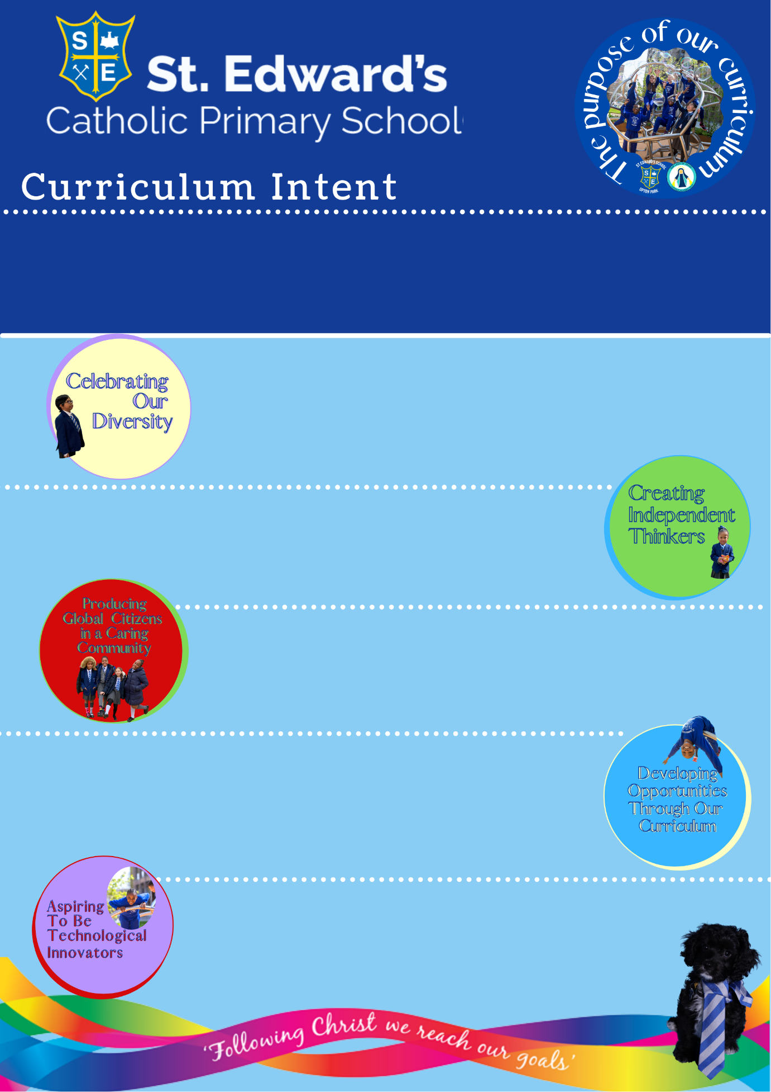

We are learning to understand the complexity of people’s lives and the diversity of societies, that we are all unique and different in many ways. To have a broad understanding of the world and develop inclusive values and celebrate diversity. To foster an inclusive and equitable learning culture.

We are learning to plan, discuss, question, analyse and to think for ourselves and form our own opinions. To predict, evaluate and assess. To build positive self-esteem. We can experiment to find solutions or a suitable means of expression. We are creative and innovative thinkers who embrace challenge.

We know that our Design Technology curriculum works in tandem with the National Curriculum, which is the ideal context for extending our literacy, speaking and listening, reading and writing. We are making our learning journeys as interactive and creative as possible.

We are learning to think critically. We are using both new and ‘old’ technological methods, ideas and products in our everyday learning experiences. We are prepared for a future in an increasingly uncertain world. We are equipped with knowledge and skills relevant to our future needs

We have a well-developed sense of our rights and responsibilities. We can become positive global citizens who can recognise our own identity in society.

Design Technology

**Design Technology**

**Context**

|  |  |  |  |  |  |
| --- | --- | --- | --- | --- | --- |
| The Design Technology curriculum is arranged according to 6 strands | | | | | |
| Design | | | | Plan | |
| Make | | | | Evaluate | |
| Technical Knowledge | | | | Health and Safety | |
| **EYFS** | | | | | |
| **Expressive Art and Design**  Make independent choices. Achieving something that’s important . Keep trying when things are difficult. Junk modelling. Links to theme and topic.  Develop own ideas. Choose appropriate materials. Props and materials in role play. | | | | | |
| **Year 1 & 2** | | | | | |
| **Year 1** |  | All About Me.  (To design, make and evaluate a photo frame and embroidered notebook) | Homes  (To investigate interior and exterior of houses. To explore combining shapes. Design and create a model house with rooms) | | Eat more fruit and veg.  (To handle and prepare a variety of fruit and veg. To design, make and evaluate a recipe) |
| **Year 2** |  | Fire Engines  (To investigate wheels, chassis and axles. To design, make and evaluate a fire engine) | Kites  (To explore the history of kites, to explore materials and to design, make and evaluate a kite) | | Puppets  (To investigate a range of fabrics, develop sewing skills, design, make and evaluate a glove puppet) |

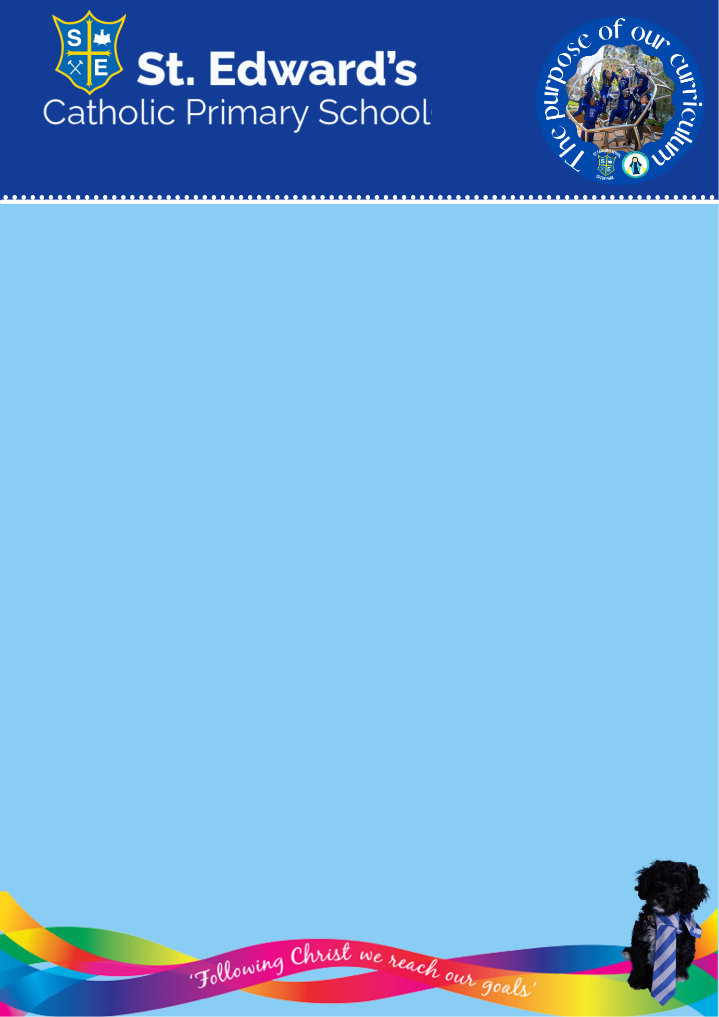v

|  |  |  |  |  |
| --- | --- | --- | --- | --- |
| **Year 3 & 4** | | | | |
| **Year 3** |  | Light Boxes  (Investigate illuminated signs. Understand how LED can be used. Develop ideas for an illuminated sign. Select tools, equipment and components. Construct a working circuit.) | Seasonal Foods  (What does seasonal mean. Which foods are grown in Britain. How seasonal fruit is grown and harvested in Britain. How fish are caught, reared and processed in Britain. Design a menu using British seasonal foods.) | Mini Greenhouse  (Explore existing greenhouses and stable structures. Investigate different materials for a mini greenhouse. Design, draw plans, make and evaluate a mini greenhouse.) |
| **Year 4** |  | American Food  (To examine the diversity of foods grown in America’s diverse climate. Discover how Indigenous people grew, gathered and cooked food. How the African slave trade influenced American cuisine) | Chocolate  (To investigate and analyse chocolate packaging. Design new packaging based on a design brief and present that design) | Money Containers  (To explore a range of money containers. To learn a variety of sewing techniques. To design and make a money container using textiles. Evaluate finished product) |
| **Year 5 & 6** | | | | |
| **Year 5** |  | African Instruments  (To investigate and analyse African instruments. To explore Kalimbas. Create an African inspired percussion instrument to use in a performance) | Bread  (Investigate and evaluate bread products. Explore ingredients of bread. Design, make and evaluate new bread product) | Funky Furnishing  (Analyse different cushion covers. Explore ways to join fabrics using sewing. Explore fastenings. Design, make and evaluate a cushion cover) |
| **Year 6** |  | Bird House  (Investigate purpose and appearance of bird boxes. learn to draw diagrams. practice woodwork skills, use tools. Design) | Fashion and Textiles  (Investigate items made of fabric. How are fabrics joined. design and item and draw pattern pieces. join fabric by sewing. Upcycle a piece of clothing using a variety of techniques.) | Building Bridges  (Explore pillars and beams, arches and trusses. Understand suspension bridges. Design, analyse and evaluate a bridge) |